**Estimation of Business Expenses**

1.Introduction

1.1Overview : Our project; estimation of business expenses will explain about how the estimates are important to allow businesses to set expectations for their customers. 1.2Purpose : This project will make clear about the purpose of an estimate in businesses . 2. Problem statement and design thinking : The problem is not having financial goals in businesses .The purpose of cost estimation is to predict the quantity, cost and price of the resources required to complete a job within the perfect scope.

2.1.Empathy map

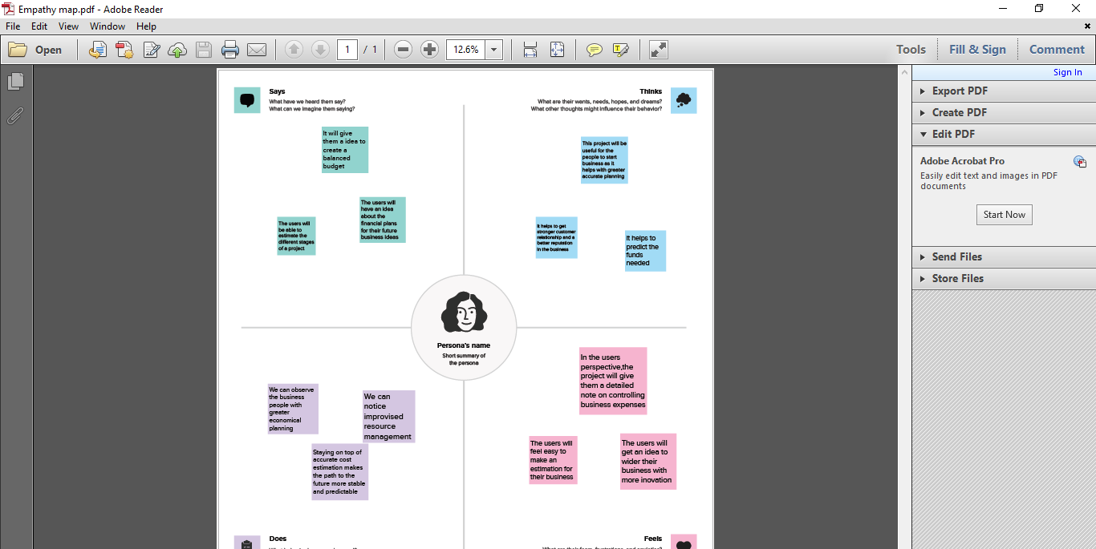

2.2.Ideation and Brainstorming

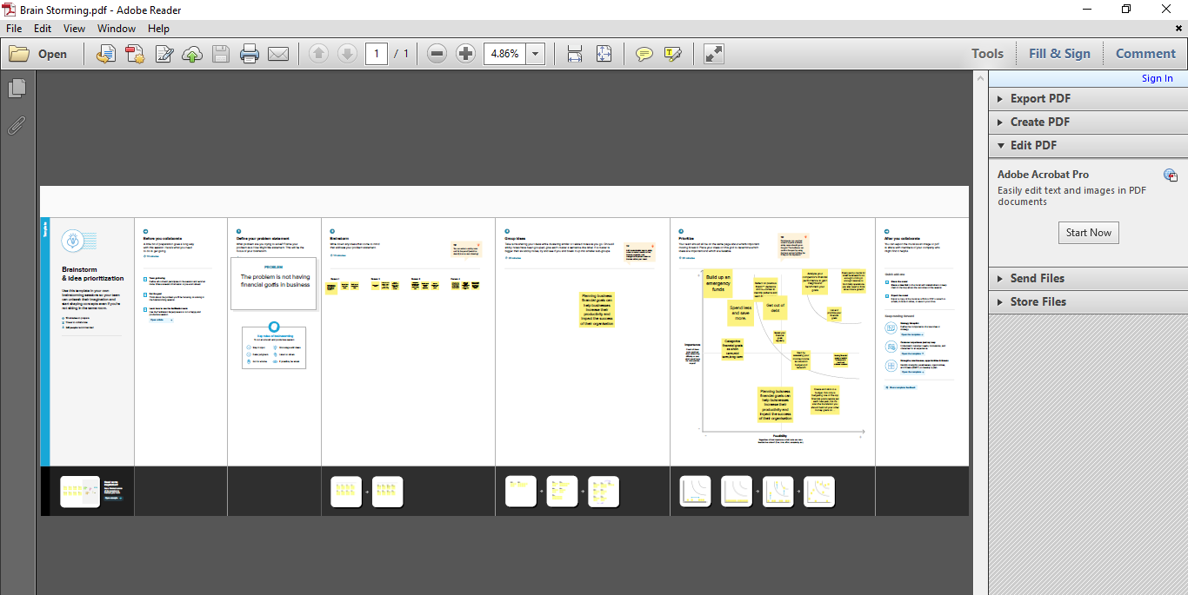

3.Result

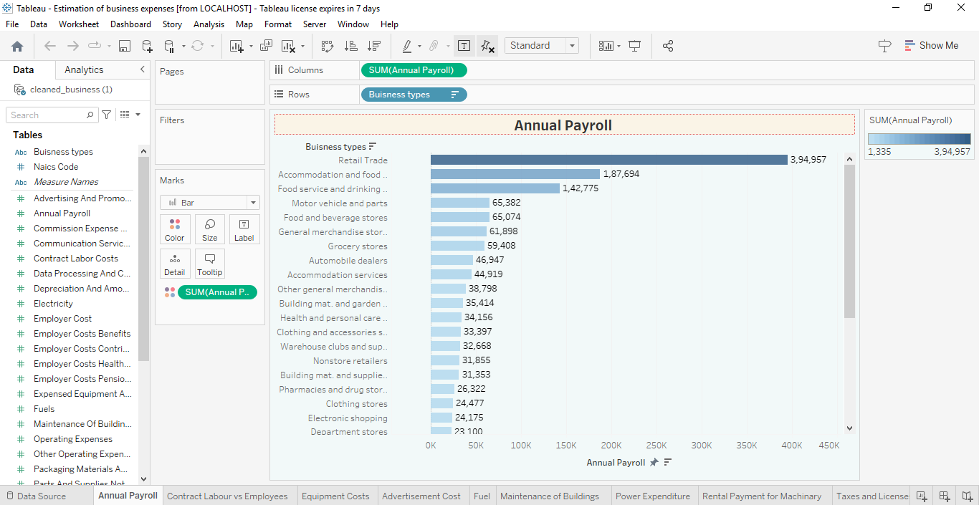

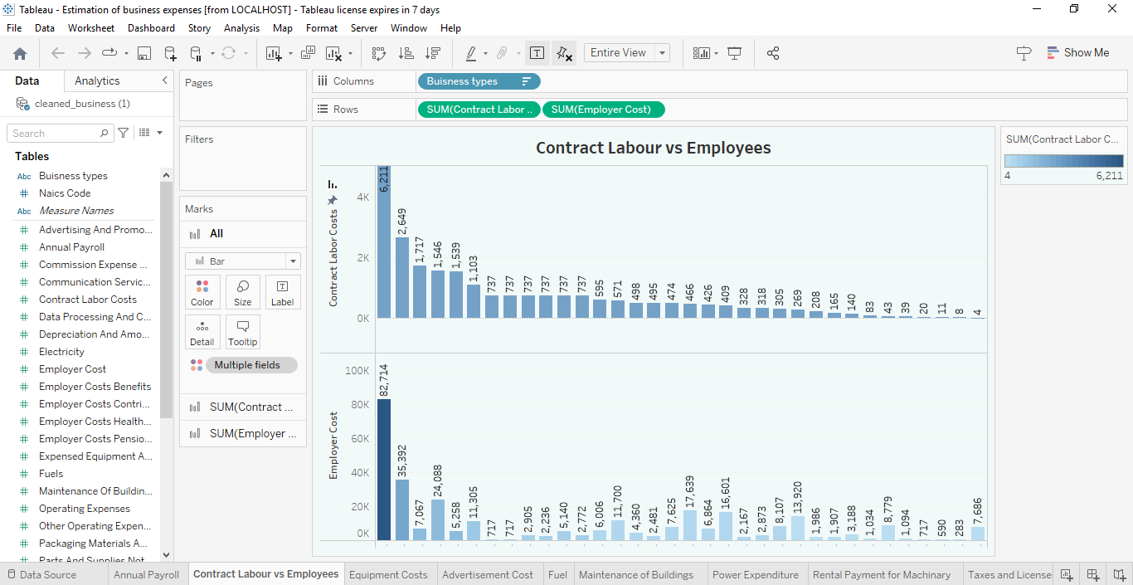

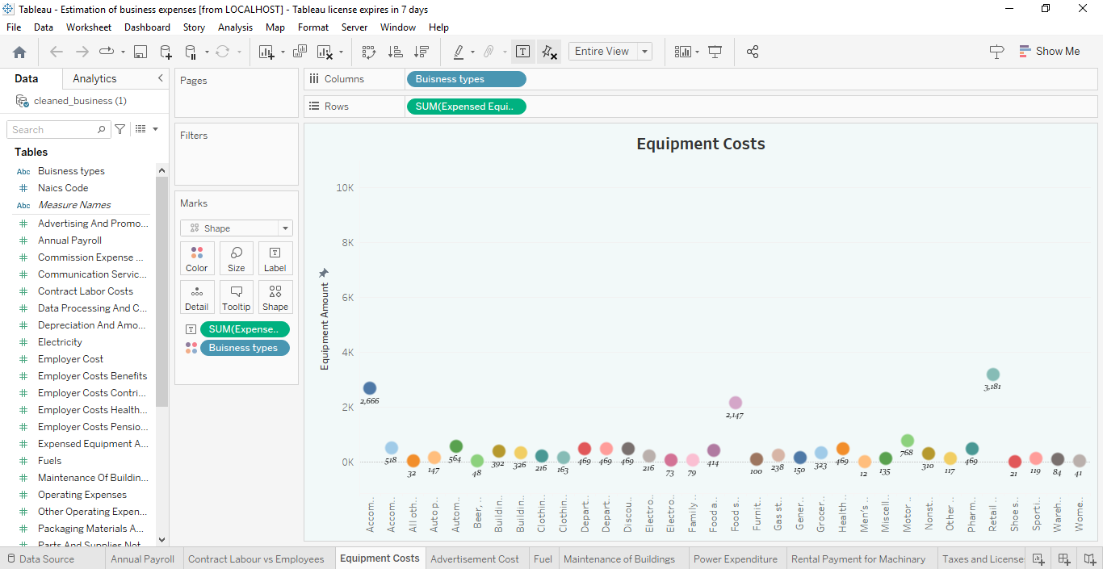

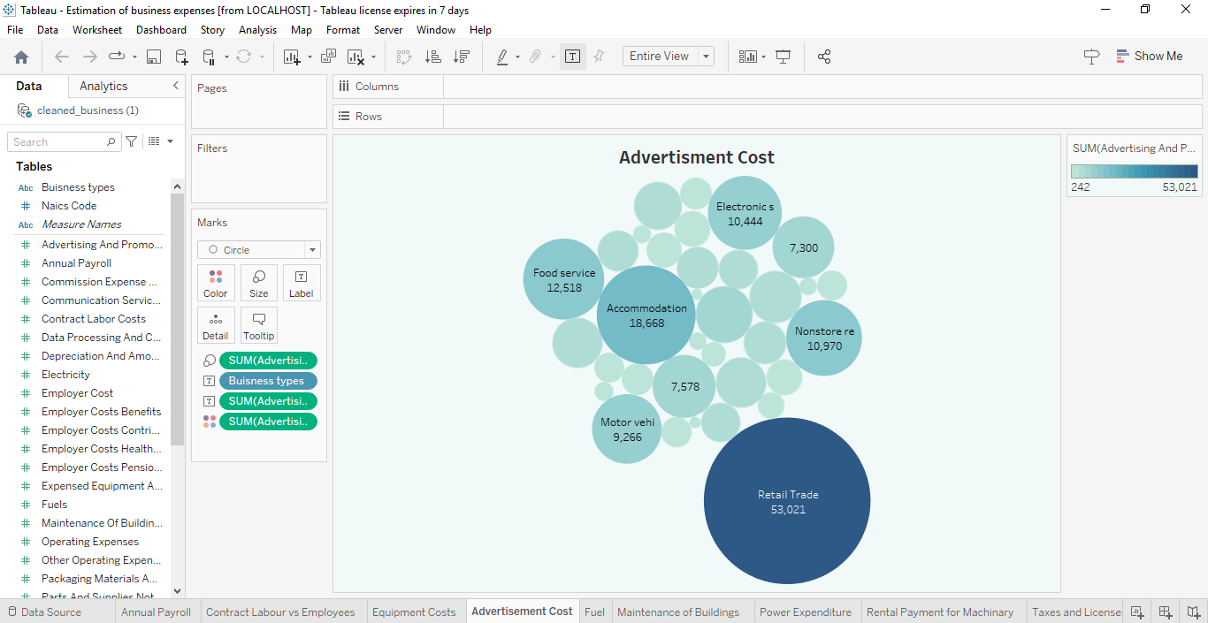

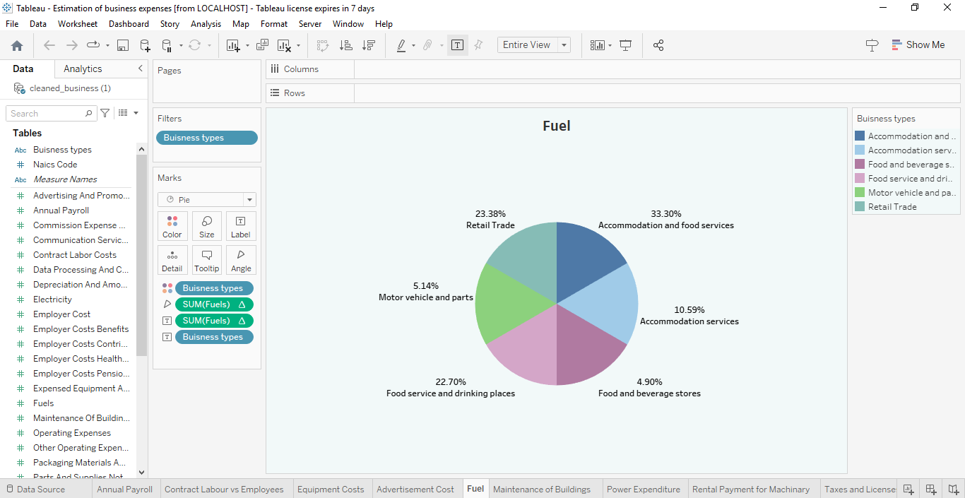

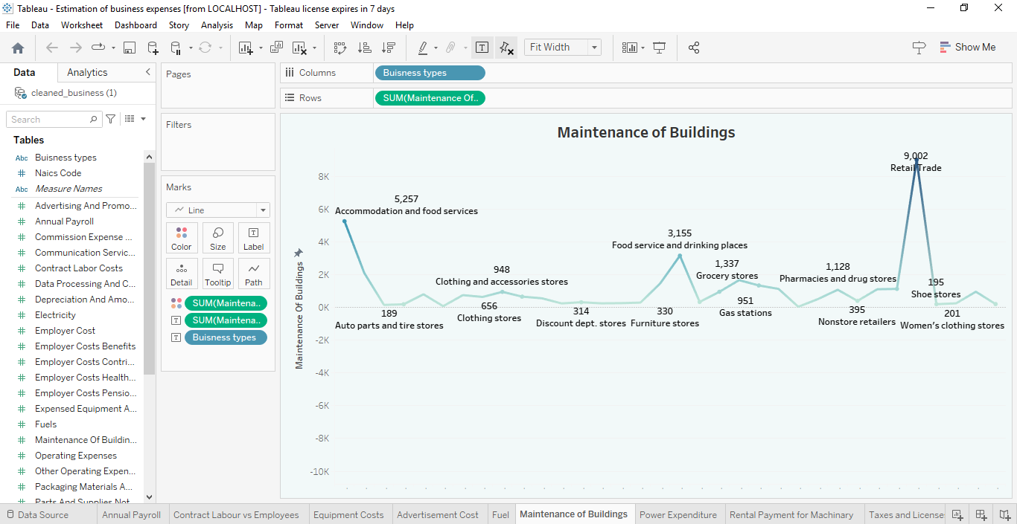

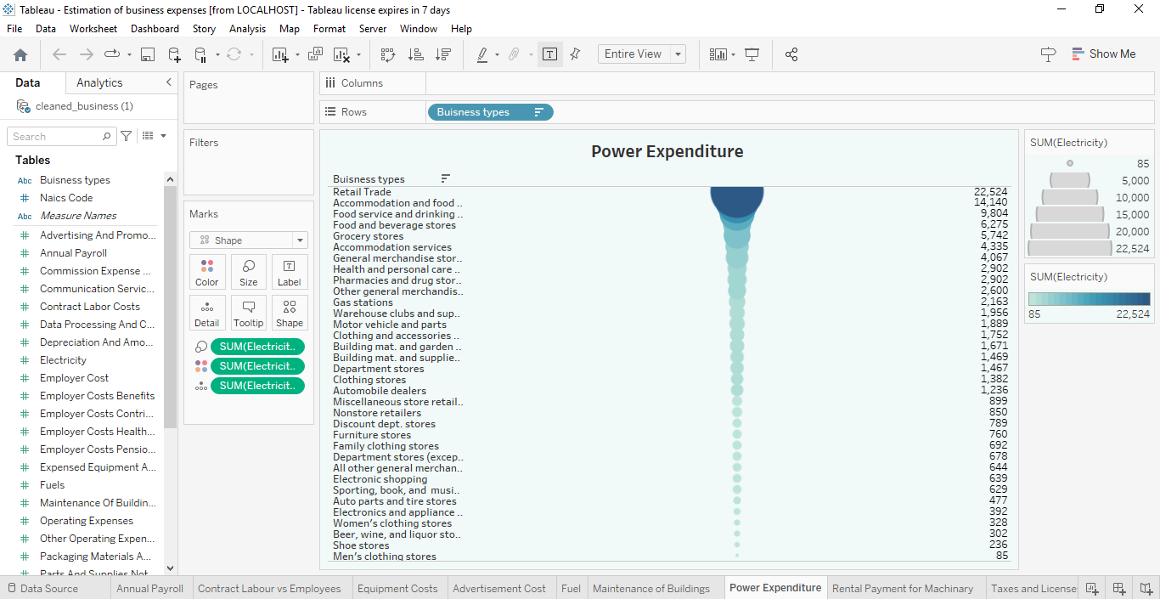

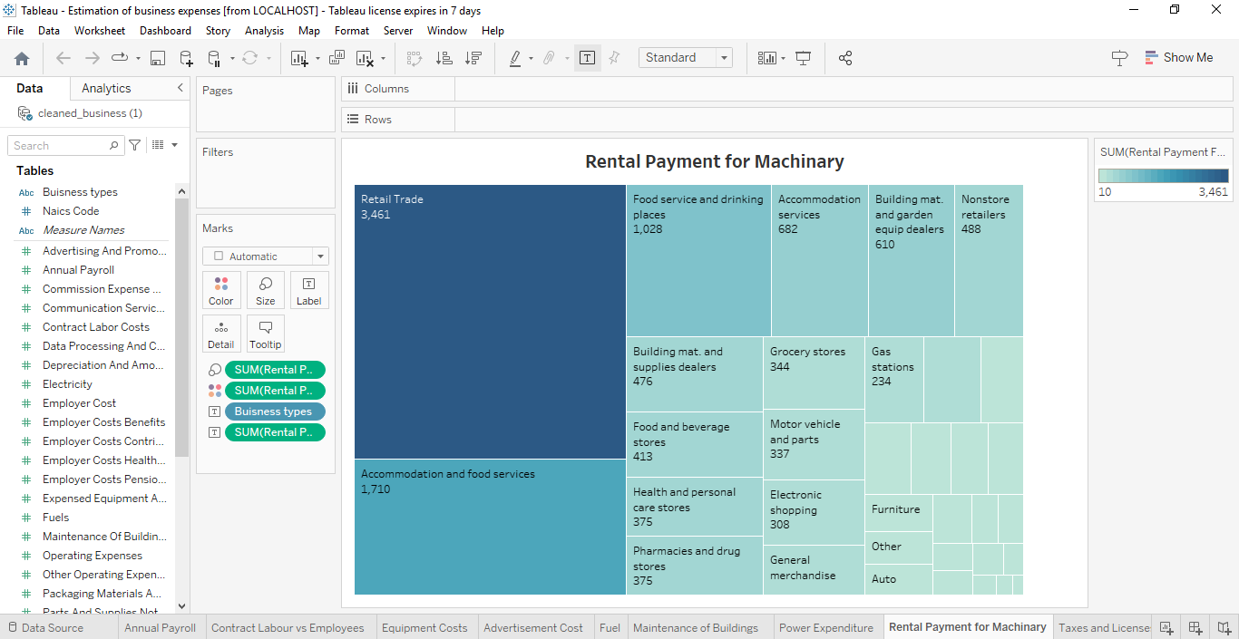

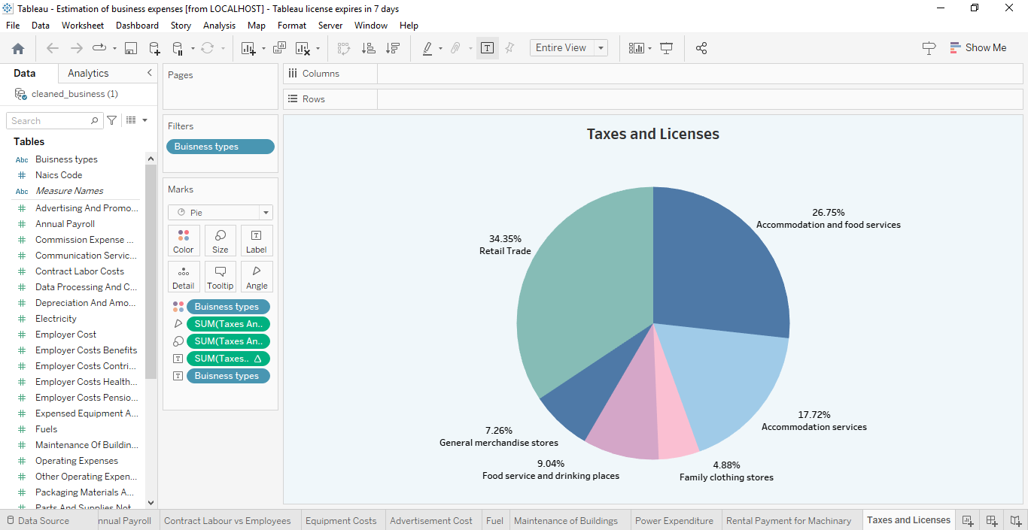

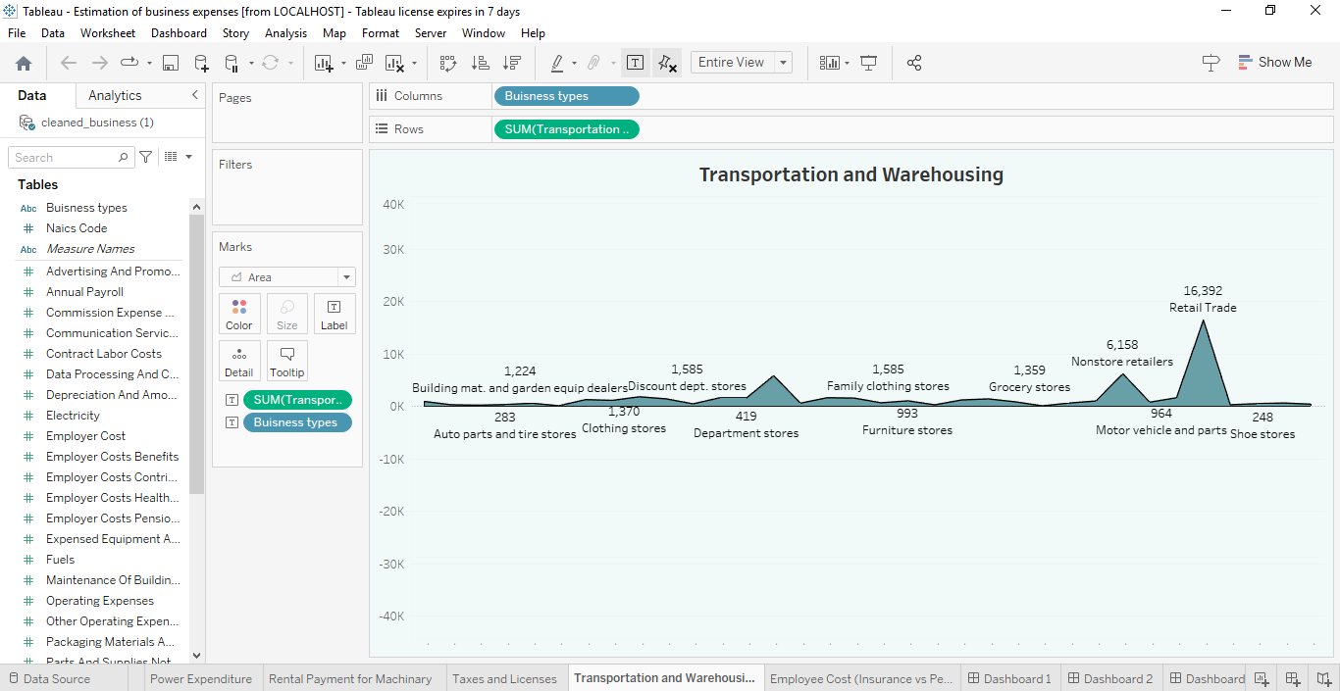

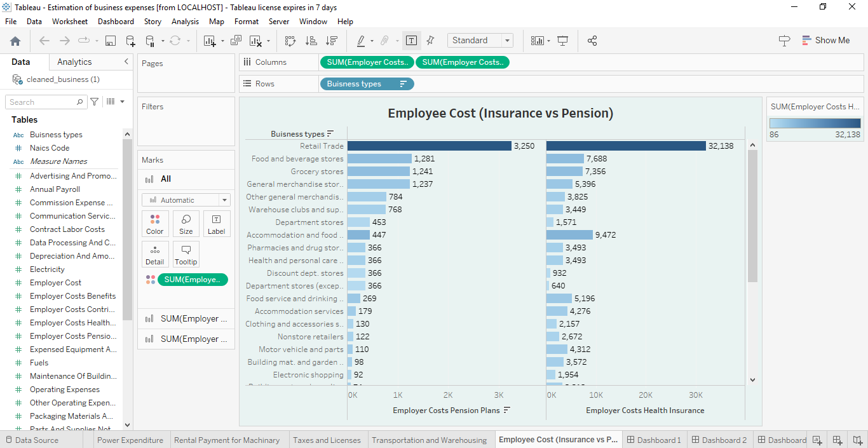

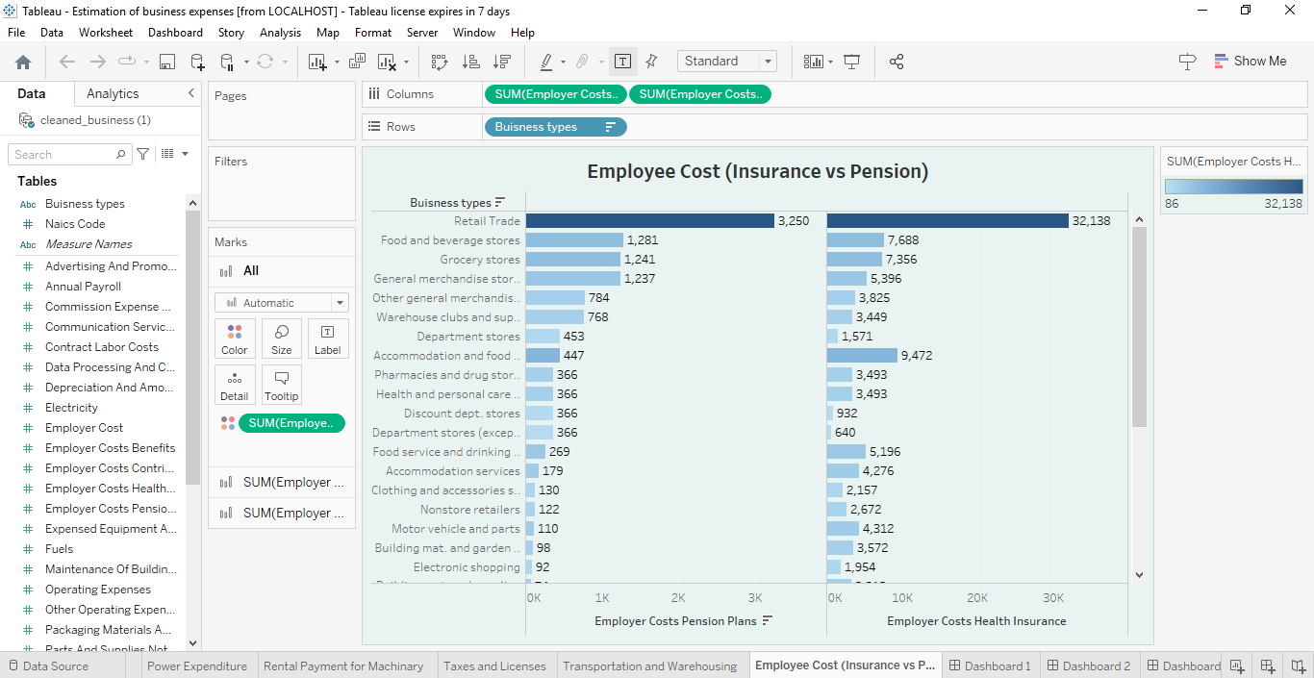

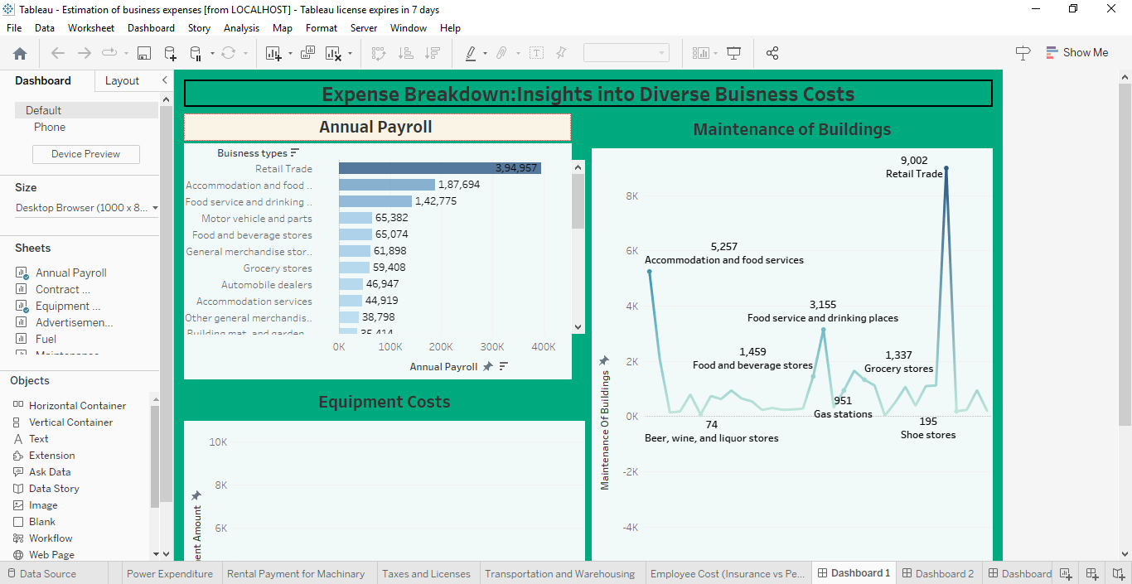

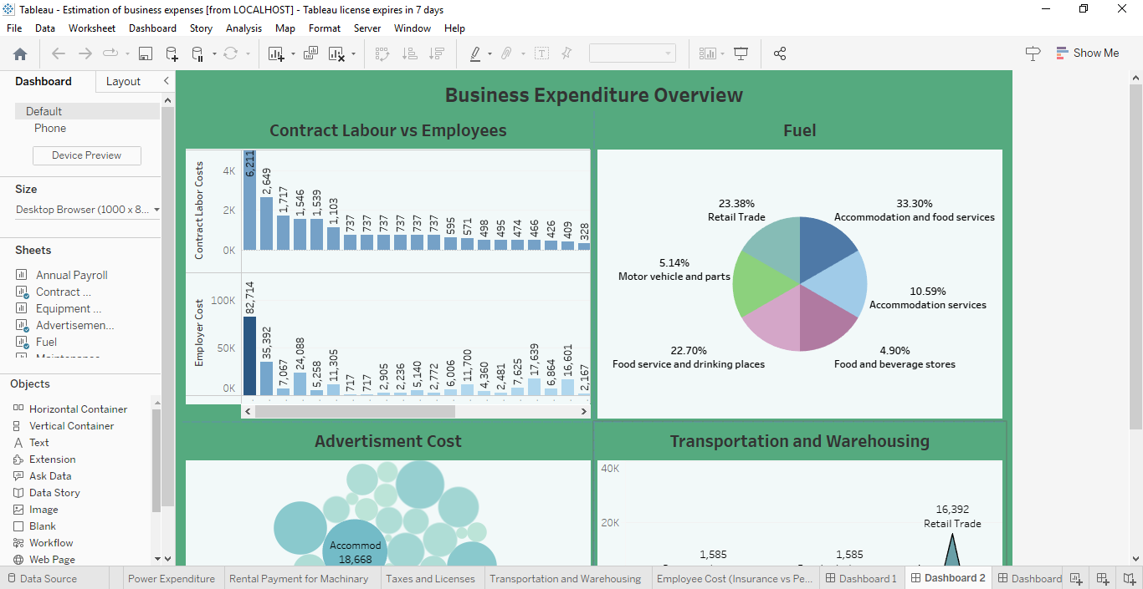

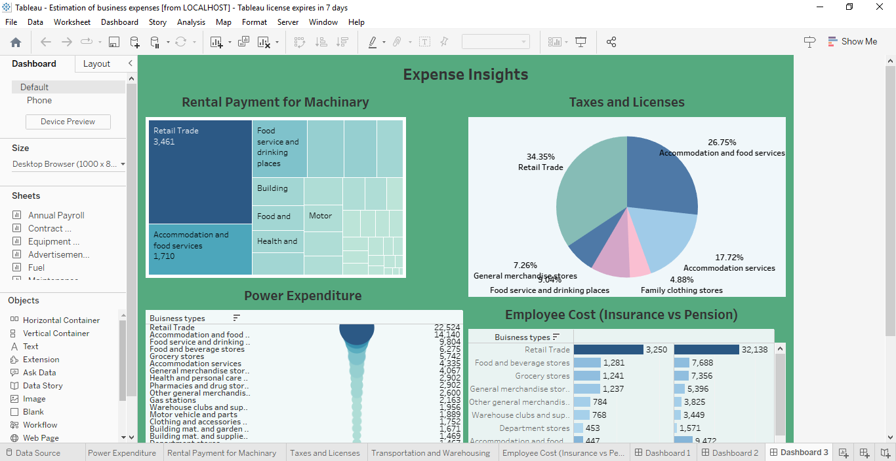

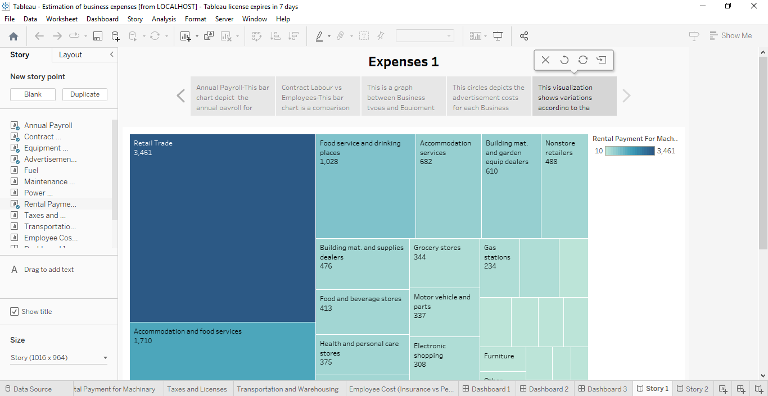

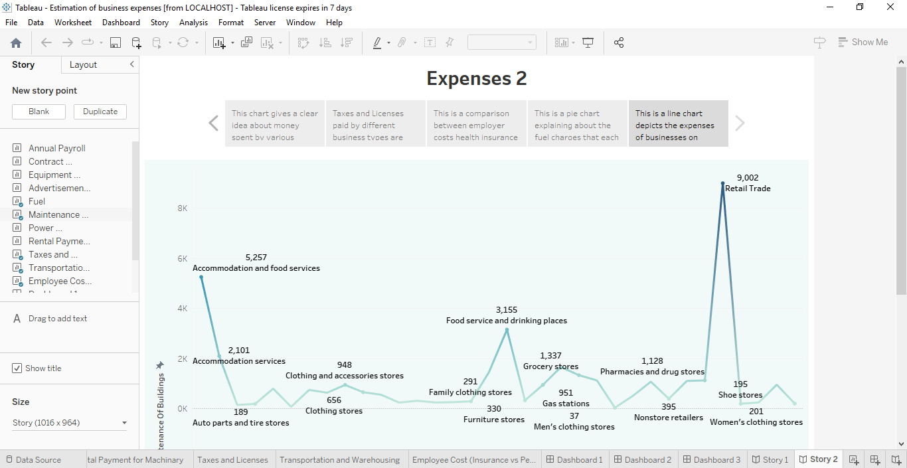

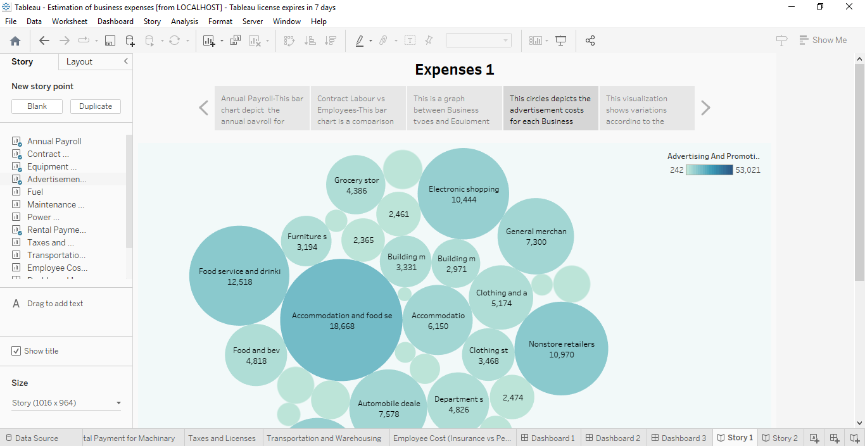

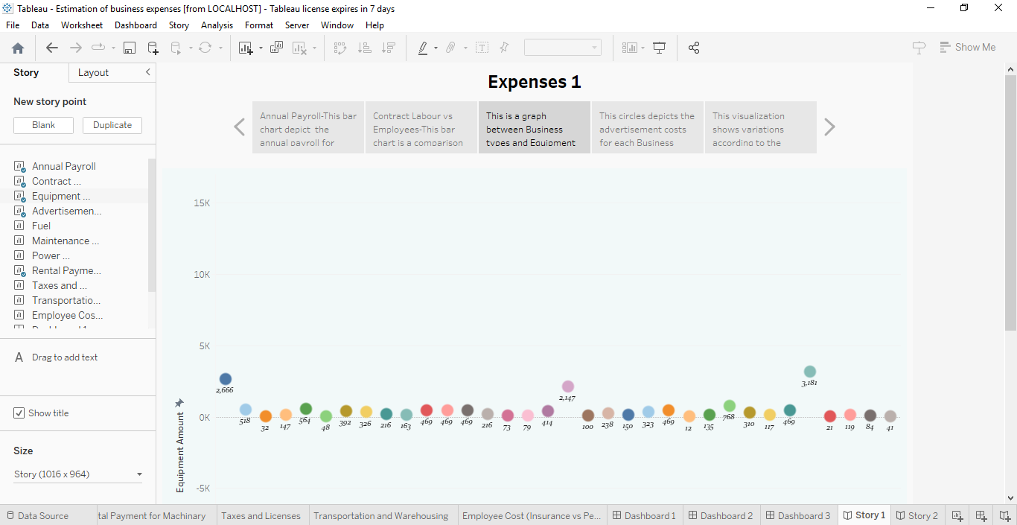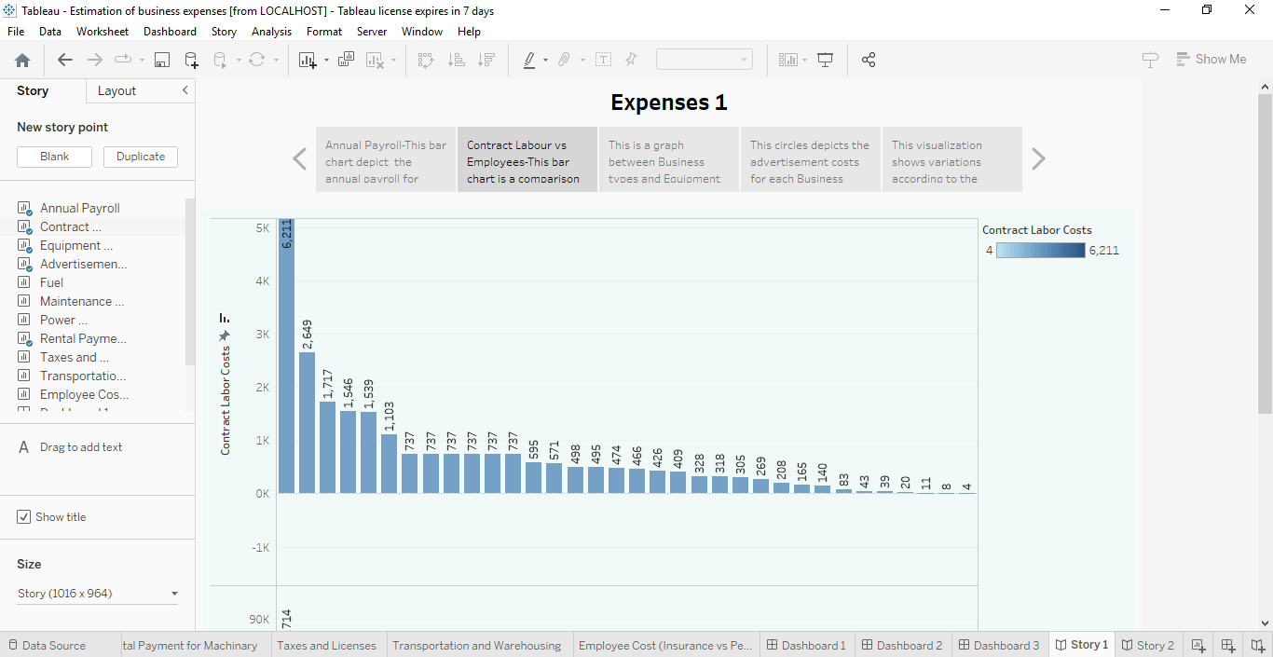

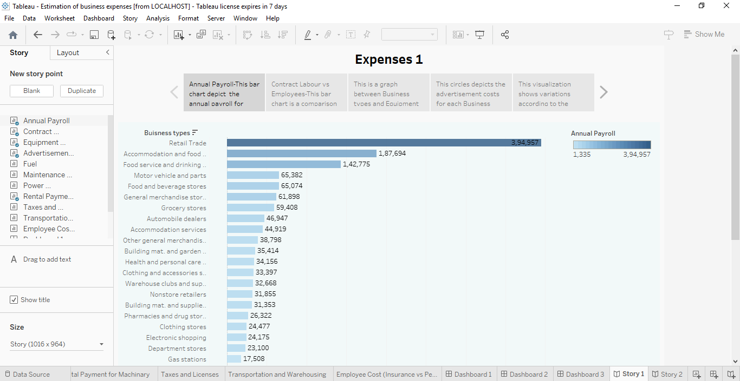

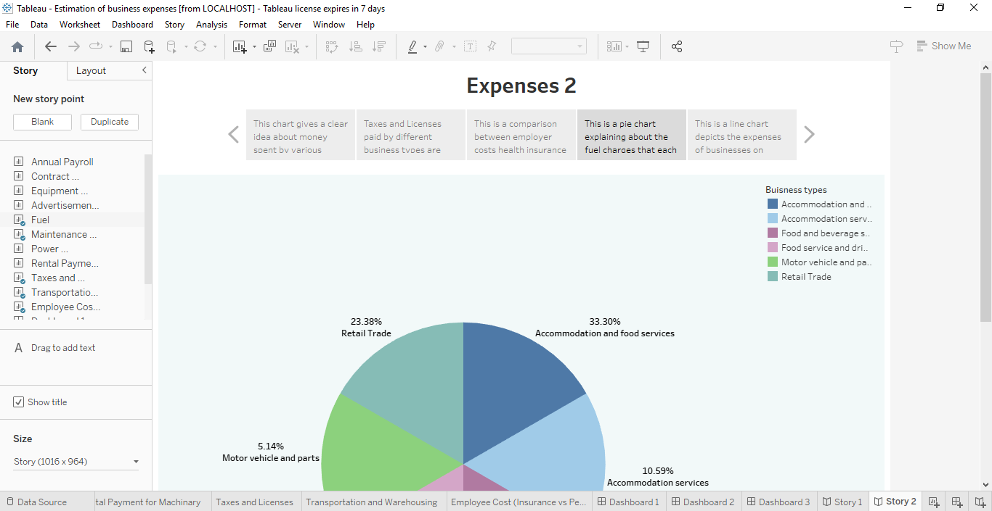

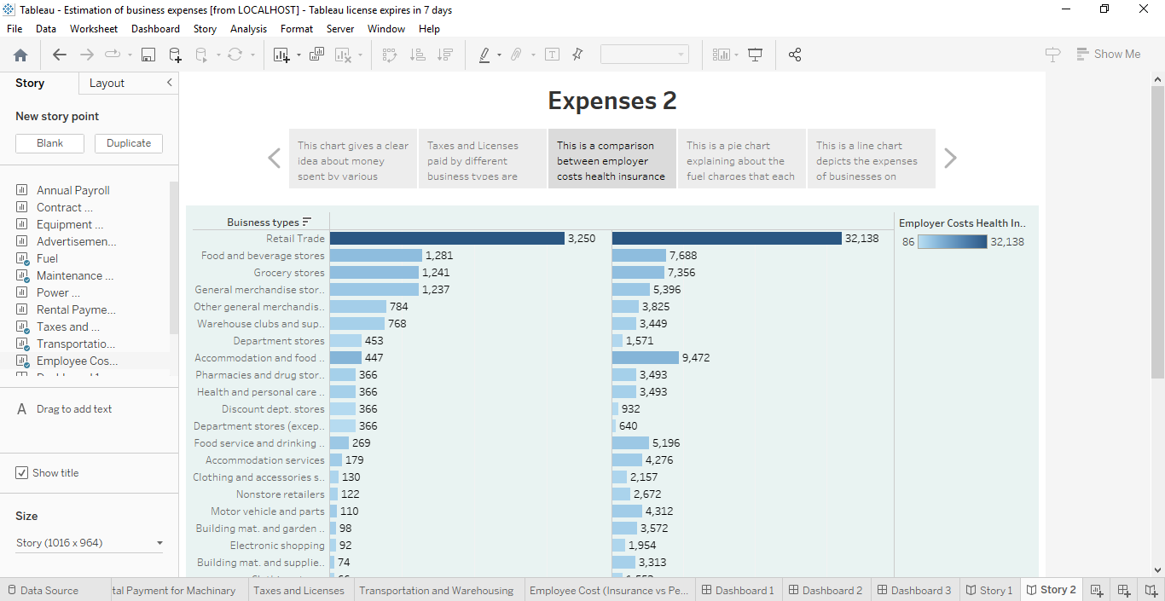

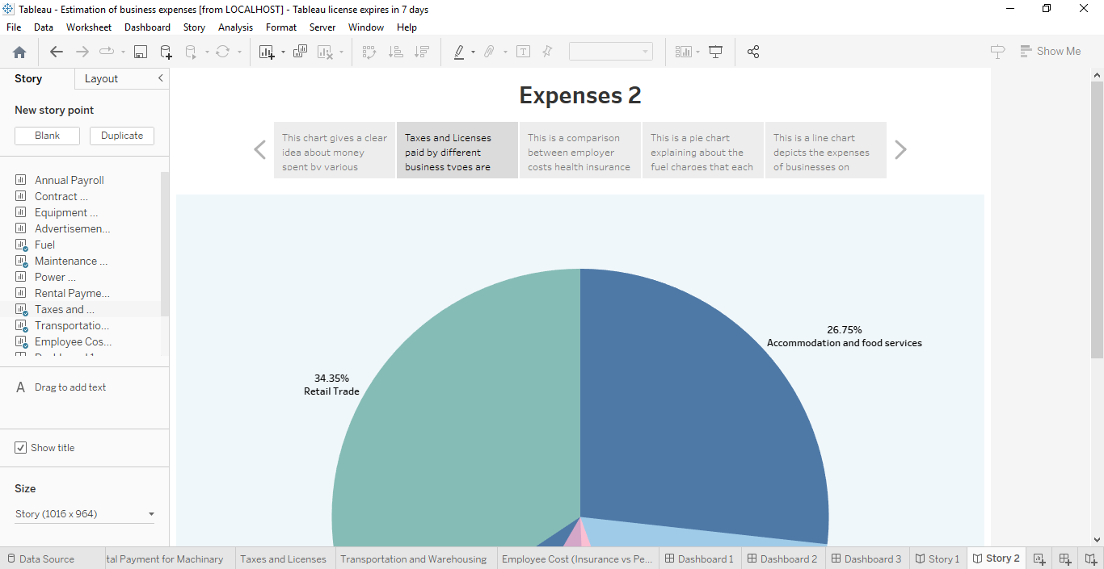

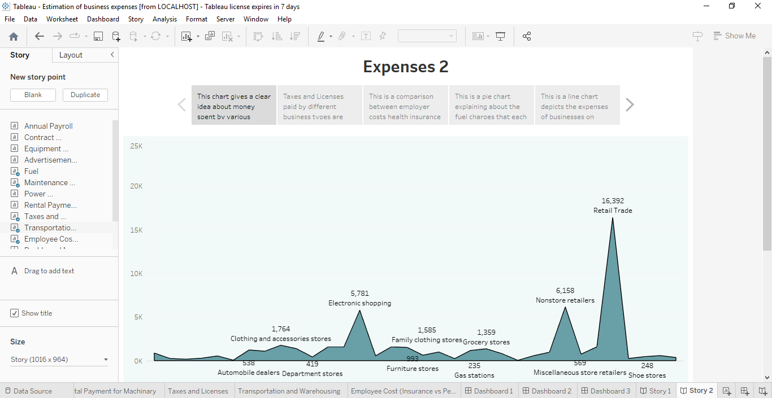

4.Advantages & Disadvantages;

* The advantage is that estimating gives us quick preliminary rough numeric calculations.

* The disadvantage is that the numbers may be inaccurate to some degree; and associated with mathematical errors and logical mistakes such as various bias and others.

5.Applications :

* We can apply the estimation theory to all small scale businesses to large scale businesses.

* Cost estimation is helpful in accounting for each element required for the project from materials to labour and calculates a total amount that determines a project’s budget.

6.Conclusion:

Thus Cost estimation sets stage for a budget that will provide adequate funding to complete a project on time and in accordance with quality standards. 7.Future scope : Estimation and costing of quantities is the primary activity for any construction or engineering job. The quantities established during initial stages determine your profitability at the end.